Greensheets re-design (8/11/2016)

## **Goals:**

* Follow up on revised awards (Additional questions and clarifications)
* On conceptual level discuss greensheets versioning and select reconciliation method (if needed).

**Additional questions and clarifications for revised awards discussion:**

1. Please clarify CBIIT understanding of the requirement that “*revisions greensheets (forms) must be part of official document file*”

That means:

1. eGrants will provide a link to revision greensheet next to award greensheets links. Link in eGrants will appear when revision greensheet is submitted (Status is ‘Submitted’ or ‘Frozen”). **That means revision greensheet will NOT be editable accessing via eGRANTS (please confirm).**
2. Should the link in eGrants disappear if greensheet has been un-submitted (status is “Unsubmitted”)?
3. CBIIT task will be to test integration point; coordination is needed between CBIIT and eGrants dev teams.

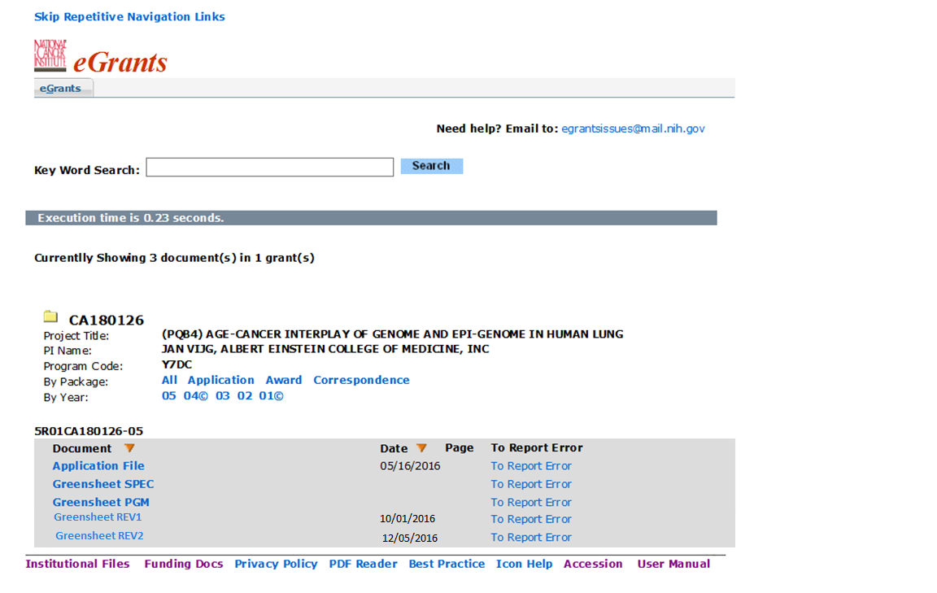

Revision link(s) will be displayed when revision GS is in status “Submitted” or “Frozen”

1. CBIIT is not planning to make any modifications to YourGrants and Notification systems related to revised awards since the users of YourGrants and Notification systems are program staff.
   * There is a search by GS status in these systems => not affected, keep search for AWARD greensheets statuses only
   * Keep displaying only AWARD greensheets according to existing rules
   * No need to modify Details report => keep displaying statuses for AWARD greensheets only

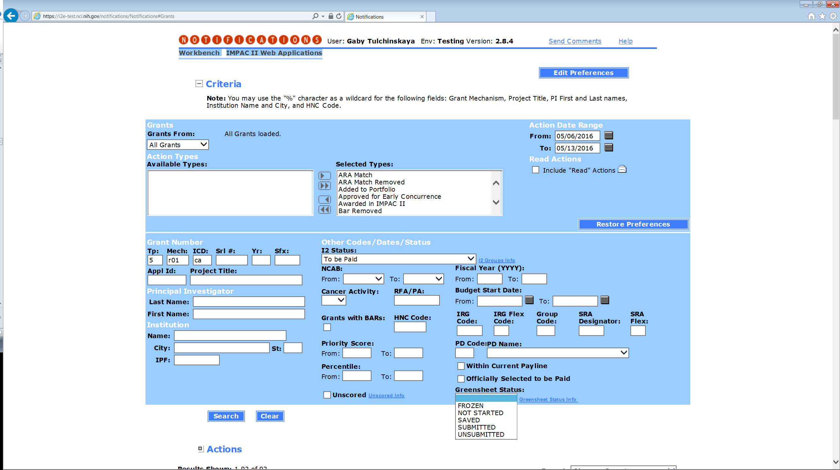

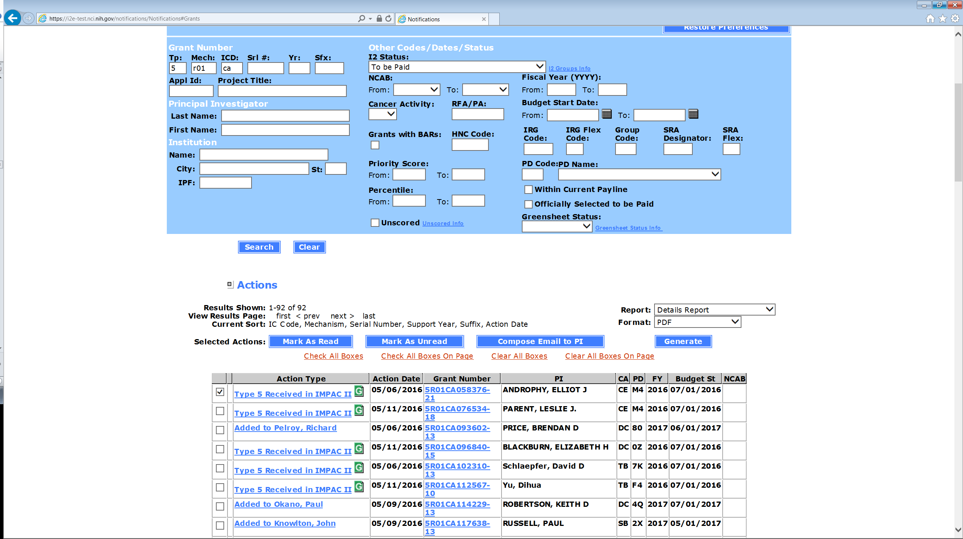

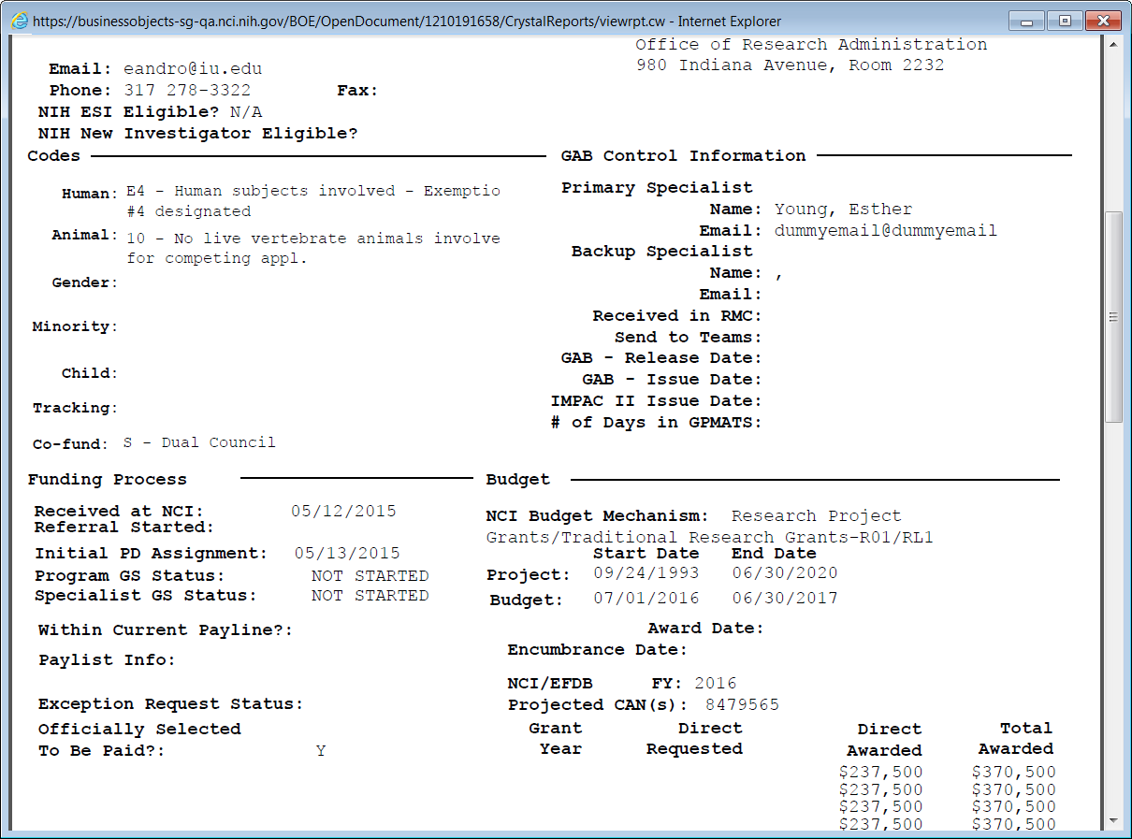

## **Greensheet versioning**

Please use mockups below the table for the discussion

|  |  |  |  |
| --- | --- | --- | --- |
| **#** | **Scenario when new FB module is promoted** | **System behavior when user retrieves greensheet** | **Options** |
| 1 | Greensheet is in status “Not Started” | Latest version of template (latest questions) is displayed | n/a |
| 2 | Greensheet is in status “Submitted” and/or “Frozen” | Version of template on the moment of submission is displayed. Read-only mode | n/a |
| 3 | Question: what is a desired behavior when greensheet is in status “Saved”? | | **Option 1**: do not display a new version of template. Let user complete and submit the version s/he started to work with.  **Option 2:** User should always complete and submit CURRENT version (latest version that has been promoted). Ability to copy appropriate data from prior version(s) should be provided. If this option is selected, see 3a below for details. |
| 3a | Greensheet is in status “Saved” (not yet submitted) | The system:   * Displays newly promoted template * Displays a message that the template has changed and instructions to a user (according to a selected option on the right) * Keeps prior version(s) of greensheet with answers and attachments (it will be displayed in read-only mode; version date will be displayed) until the next version is submitted. User can open this version in a separate browser window. * For the next step – see options (OGA needs to select) * After submission of the current version, prior versions will be deleted | **Option 1:**   * All answers should be re-entered again manually from scratch (no automatic matching) * Provide ability to copy attachments from prior version into ANY question in latest (current) version |
| **Option 2:**   * Attempt automatic match of the answers (copy from **LATEST** prior version into the current version) and copy attachments. Question: Should we do partial reconciliation (e.g. question text did not change, but answer options changed (from Y/N to multiple dropdown options). We cannot reconcile the answer, but we can copy attachments and comments)? * Provide a warning that matching is approximate and may not be correct. Allow user to edit answers and move attachments around. Provide a message if some answers/attachments don’t match at all. * Still provide ability to copy attachments from prior version into ANY question in latest (current) version |
| 4 | Greensheet is un-submitted after new module is promoted | Same as in scenario “Greensheet is in status “Saved” (not yet submitted)” |  |

Figure1: Proposed functionality for OPTION 1

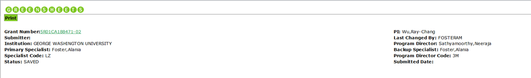

The greensheet template has been updated and the questions might have changed. Please re-enter the answers and, if necessary, move attachments into this version.

NOTE: after submission of current greensheet, the prior version(s) and all prior attachments will be DELETED.   
To copy attachment (if exists) from prior version, click on attachment icon on this screen for a selected question

**View prior version(s):** 06/20/16 04/18/2016

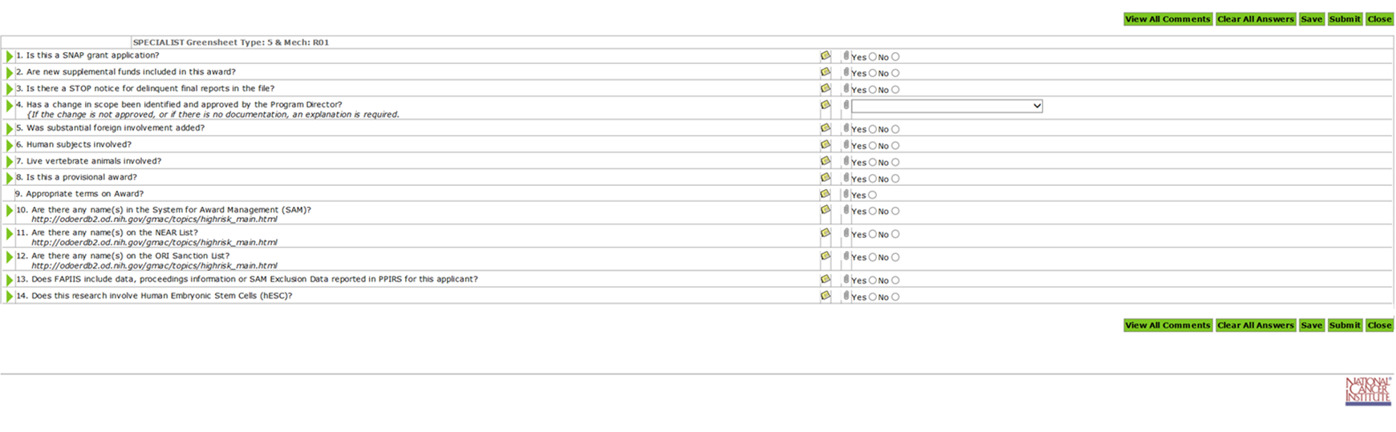

Figure 2: Proposed functionality for Option 2



**The greensheet template has been updated and the questions might have changed. The system automatically matched the answers and attachments to the questions that did not change (if any). Please check for correctness and enter answers to the updated questions.**

**NOTE: after submission of current greensheet, the prior version(s) and all prior attachments will be DELETED.**

To copy attachment (if exists) from prior version, click on attachment icon on this screen for a selected question

**View prior version(s):** 06/20/16 04/18/2016

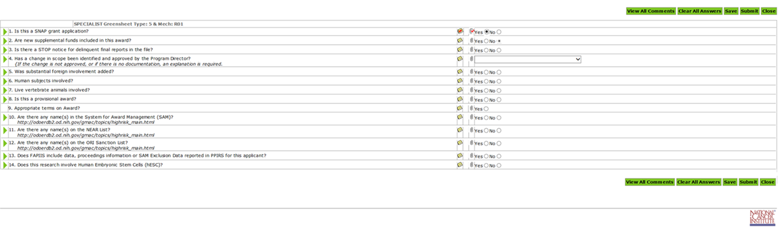

NOTE(s):

1. The system should accommodate multiple prior versions. Theoretically, it is possible that:
   * A new template has been promoted from FB,
   * Users started to work on current version, but did not submit them yet,
   * And a new template has been promoted again.

Even if it might be not probable, but the system should have handle such situation without breaking.

1. The message and “View prior version(s)” label will be displayed only if prior version(s) exist. The dates indicate the date(s) when the form for this template become read-only.
2. Please confirm: Report in FormBuilder that ties the version of template to type/mech should have an “expiration date” (when new version got promoted). It will be easier to query later.

When user selects a prior version (by clicking on a date link), it will be open as read-only in a separate browser window.

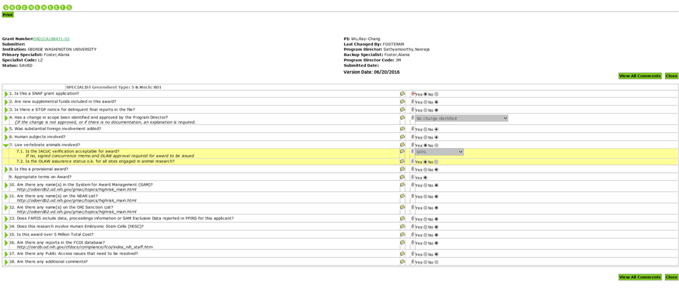

**User flow for Option1:** user will open old version in a separate browser window, and do the following:

* Compare the questions/answers and manually re-enter answers
* Open the comments and manually copy comments into a current version into appropriate question (if needed)
* Attachments (user clicks attachment icon in CURRENT version window for a specific question).

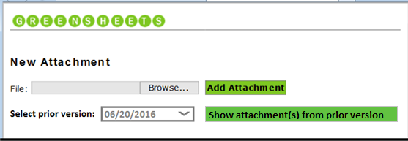

Please choose the option:

* Option 1: Always display “Select prior version” dropdown and corresponding “Show attachments…” button if prior version(s) exist. The dates in the dropdown indicate the date(s) when the prior version(s) become read-only.
* Option 2: Display “Select prior version” dropdown and corresponding “Show attachments…” button **only if non-reconciled questions** from prior version(s) exist (*can be dangerous if partial reconciliation is allowed*).

New Attachment pop up will be modified, allowing to:

* + Add attachment, as we do now
  + In addition, ability to copy attachments from prior version will be provided. If user clicks “Show attachment(s) from prior version” button, the system will display the list of questions from prior version that had attachment(s). User can select a question and click Copy. All attachments for selected question will be copied into the question in current version, for which user originally clicked 

If user clicks Add Attachment: we will keep existing functionality:

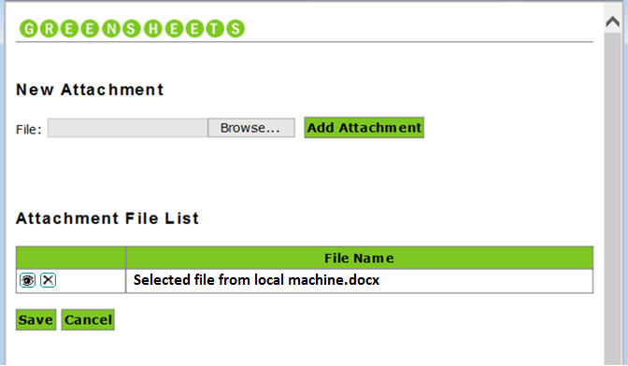

**Attachment File List**

|  |  |
| --- | --- |
| **File Name** |  |
| Attachment name 1.docx | Delete |



If user clicks “Show attachment(s) from prior version” button, the list of all questions that have attachments from a selected version will appear. Question: Do we need to show ALL questions with attachments from selected version or only non-reconciled questions with attachments?

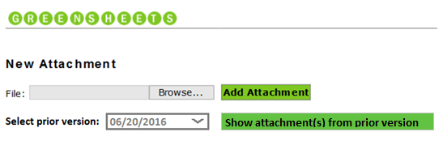

|  |  |  |
| --- | --- | --- |
| **Questions with attachments from 06/20/2016** | **File Name** | **Action** |
| Is this a SNAP application? | Attachment name 1.docx |  |
| Attachment name 22.docx |
| Is this a provisional award? | Email PDF1.pdf |  |
| Is this award over 5 Million Total Cost? | Doc3333.doc |  |

User will request to copy attachments from a selected question; all attachments will be moved into “**Attachment File List”** section. User can delete or view any attachment. User can add attachments from different question into the selected question for a current version.



|  |  |  |
| --- | --- | --- |
| **Questions with attachments from 06/20/2016** | **File Name** | **Action** |
| Is this a SNAP application? | Attachment name 1.docx |  |
| Attachment name 22.docx |
| Is this a provisional award? | Email PDF1.pdf |  |
| Is this award over 5 Million Total Cost? | Doc3333.doc |  |

**Attachment File List**

|  |  |
| --- | --- |
| **File Name** |  |
| Attachment name 1.docx | Delete |
| Attachment name 22.docx | Delete |
| File that user added manually into a current version.doc | Delete |



**User flow for Option2:** same as for option 1, except that initially the system will automatically copy answers/comments/attachment from the **LATEST** version (if any). Ability to view all prior versions will still be provided and user can manually copy attachments and from them.